GRC 102 WEEK 4
GRC 102 W4=Nander Ndam-C11/26/CGRCE/17571
Task 1
Auditd Configuration Events
Evidence verifying Lynis installation
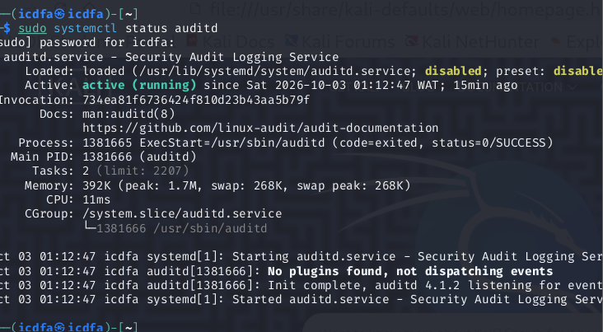

Activity 1.2
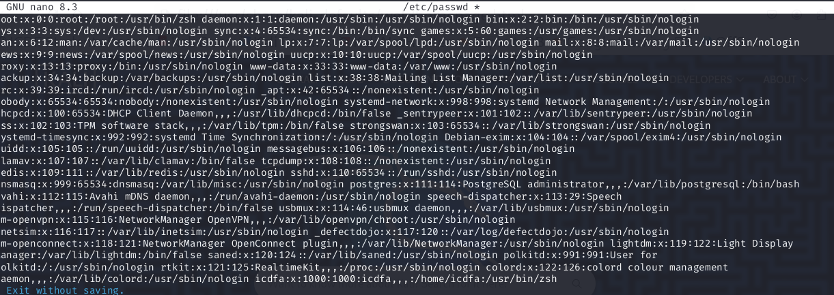

Activity 1.3
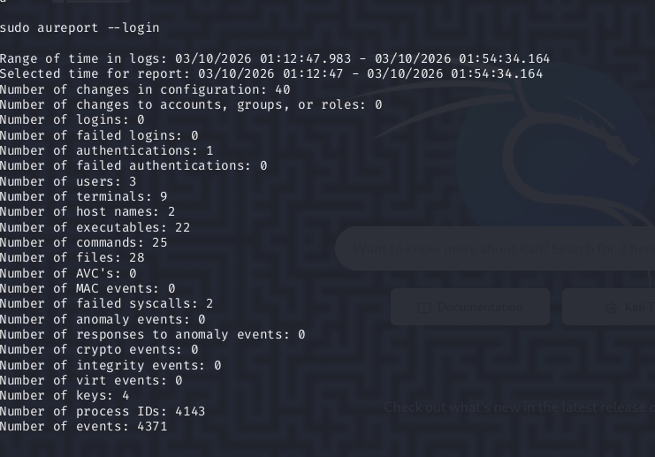

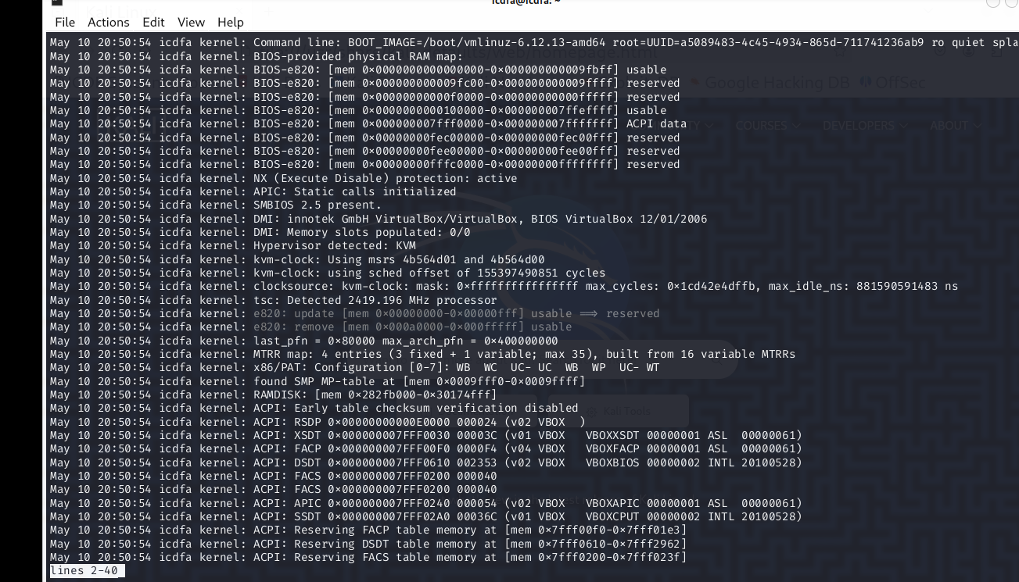

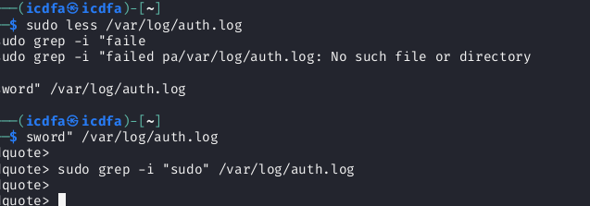

Module 3. Lynis successfully installed
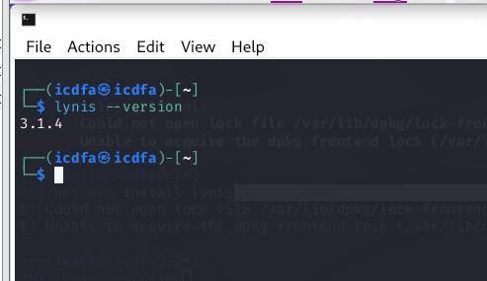

Key Results

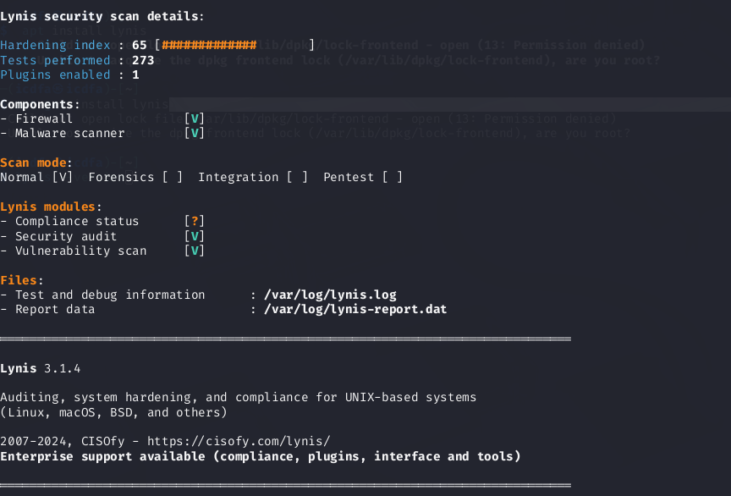
Three findings
- Hardening index scored 65 out of 100 which indicates that there are security gaps or unminimized attack.
- The compliance scanner could not determine compliance status and has a risk of legal penalties
- The tool was used during the normal scan mode
- Linux is likely owner
- Review full log and report files for remediation
Question 8
Evidence from auditd, journalctl, authentication logs, and Lynis can be forwarded to an enterprise SIEM or GRC platform. The SIEM can collect, correlate and alert on security events, while the GRC platform can track recurring weaknesses and control performance.
- Technical operational alerts: Failed login attempts, unusual privileged activity, service failures, configuration changes, and individual Lynis recommendations should initially be handled by the SOC/IT team for investigation.
- Governance/control-assurance issues: Escalate when evidence shows a required control is missing, repeatedly failing, operating outside policy, or lacks reliable evidence of operation. For example, repeated unauthorised configuration changes or unresolved Lynis findings that violate an organisational security requirement.
· Low Lynis hardening score – 65/100
This indicates unresolved security weaknesses that should be reviewed and tracked to remediation.
· Unresolved compliance uncertainty
The Lynis compliance scanner could not determine the system's compliance status. This warrants governance attention because the organisation cannot clearly demonstrate whether required controls are being met.
· Potentially inadequate audit/logging coverage
The audit evidence should be reviewed to confirm that important security events are being captured. Missing audit coverage can prevent the organisation from demonstrating that controls are operating effectively.
Control / Objective | Evidence | Owner | Observed Status | KPI/KRI or Threshold | Risk / Significance | Remediation | Retest / Follow-up
System hardening | Lynis hardening score | IT/Security | 65/100 – gaps identified | Target ≥90/100 | Increased attack surface | Address actionable Lynis findings | Re-run Lynis after remediation
Compliance monitoring | Lynis compliance scan | GRC/Compliance | Compliance status undetermined | Compliance status should be confirmed | Cannot demonstrate compliance | Map controls to applicable requirements | Repeat compliance assessment
Security logging | auditd records | IT/Security | Audit evidence collected | Required security events logged | Reduced visibility of security activity | Review and enable required audit rules | Review audit logs periodically
Authentication monitoring | Authentication logs | SOC/IT | Login activity monitored | Investigate repeated failed logins | Possible unauthorised access | Investigate unusual/repeated failures | Follow up on alerts
System/service monitoring | journalctl | IT/Security | System events available | Critical errors investigated | Service disruption or security issues may go unnoticed | Investigate recurring errors | Review logs and confirm resolution

· Highest priority:
The 65/100 Lynis hardening score and unresolved security gaps, because they indicate weaknesses that may increase the system's attack surface.
· Remediation owner:
IT/Security: hardening, logging and authentication issues.
GRC/Compliance: compliance assessment and control tracking.
· Escalation threshold:
Escalate when a critical finding remains unresolved, a control repeatedly fails, or remediation exceeds its agreed deadline.
· Successful remediation evidence:
A clean/reduced Lynis finding, updated logs showing controls working, and documented compliance/control evidence.
· Retesting:
Retest after remediation and within the agreed control-monitoring cycle, using Lynis and the relevant system logs.

